Kingsbury Parish Council Minutes

Meeting of Kingsbury Parish Council held on Wednesday 27th November 2024, at 6:45pm at Woodlands Community Centre, The Woodlands, Wood End, CV9 2PT

Present Councillors: J Thomas, A Jenns, I Thomas, A Phillips, O Phillips, M Moss, J Given, V Barker and H Phillips

Apologies: Received and accepted Councillors M Wilson and D Bates.

Minute Taker: Councillor A Phillips

Notes | Action
395. Public Participation
No members of the public attended the meeting however one Piccadilly resident raised through their Cllr concerns regarding yellow lines for the village which were confirmed not to be proposed for Piccadilly.

396. Police Matters
PC Beale attended the meeting in person.

PC Beale reported on several incidents that had been raised to the police across the 5 villages. In Wood End and Kingsbury the majority of these incidents had involved ASB, while for Piccadilly, Hurley and Bodymoor Heath, the incidents had been more road related. PC Beale also confirmed that Operation Reduce was a multi-agency approach to reducing crime which also meant working with Staffordshire and West midlands police.

Cllr I Thomas reported that he’d tried to see the PCC in Atherstone but that he wasn’t present although his staff were. He reported to them that residents were failing to report crime due to the inefficiencies of both 101 and general police responses to crime. PC Beale did acknowledge that he and the police were aware of other crimes that had gone unreported and stressed the need for crimes to be reported appropriately to create records and statistics which are used to direct resources.

Cllr A Phillips thanked PC Beale and the rest of the policing team for their involvement with the ASB within Wood End.

Cllr J Given asked PC Beale about who was responsible for mud on highways and if this were a police matter. PC Beale confirmed that it can be reported to police but that they will redirect it to highways directly. The onus should be farmers to ensure the roads are clear of mud as this was their responsibility.

Cllr A Jenns mentioned a Cliff resident who has been using threatening language. PC Beale confirmed that the resident has been visited by the police and further incidents should be reported to the police where is can be reviewed and escalated if necessary.

397. Apologies
As noted, above.
398. Declaration of Personal and Prejudicial Interests
All Declarations of Personal and Prejudice Interests as follows:

- Councillors J Thomas and I Thomas declared a personal interest in any minutes relating to HS2.
- Councillors I Thomas and J Thomas declared a personal interest in any minutes relating to the Special Management Zone in North Warwickshire
- Councillor J Thomas declared a personal interest in any minutes concerning Bodymoor Heath Victory Hall Committee and Piccadilly Community Centre.
- Councillor I Thomas declared a personal interest in any minutes concerning Piccadilly Community Association.
- Councillor A Phillips declared a personal interest in any issues relating to Woodend Village Hall and Hurley Primary School.
- Councillor A Jenns declared a personal interest in any issues relating to NWBC and WCC.
- Councillor D Bates declared a personal interest in any issues relating to NWBC.
- Councillor H Phillips declared a personal interest in any issues relating to NWBC.
- Councillor J Given declared a personal interest in any issues relating to Hurley Community Association.
- Councillor O Phillips declared a personal interest in any issues relating to NWBC and Woodend Village Hall.
- Councillor M Wilson declared a personal interest in any issues relating to The Royal Oak, Kingsbury.

Additional Declarations related to the agenda not mentioned above:

- Cllr I Thomas was outside the venue whilst interviews for the Clerk took place.
- Cllr A Jenns declared an interest in the grant application for the Kingsbury Good neighbours group.
- Cllrs A, O and H Phillips all declared an interest in the grant application for Wood End Village Hall.
- Cllr J Given reconfirmed his interest in the grant application for the Hurley Community Association.

399. To Receive and Approve Minutes
The minutes of the meeting of Parish Council held on Tuesday 22nd October 2024 to be received & approved as a correct record
Proposed by Cllr H Phillips and Seconded by Cllr I Thomas no one Against or Abstained, all Councillors in Favour. – Minutes signed by Cllr J Thomas.

400. Matters Arising from Previous Minutes:  Item 325: APNR/Speeding - Cllr J Thomas confirmed that she had spoken to police regarding possibility of funding, unfortunately however this is not looking like a potential opportunity. Cllr A Jenns recommended contacting Chris Lewis to consider mobile cameras. Cllr A Jenns confirmed he would follow up on this and report back.  It was also recommended that contact is made with MP to seek support. Cllr I Thomas to attend meeting and Cllr J Thomas to contact MP.  Item 295:  - Piccadilly Railway Fence: Outstanding – Cllr J Thomas to seek support from MP  - Bodymoor Heath Bridge: Outstanding – Cllr J Thomas confirmed she had spoken to the MP who had advised that this is discussed with the Police and Crime Commissioner first. Cllr I Thomas also offered to attend a meeting scheduled for 5th November 2024 regarding funding.  - Piccadilly Bridge Flooding: Flooding appears to be resolved; however, attention is required on path. Cllr A Jenns to follow up on this with County.  - Bin Dexter Lane: Cllr O Phillips wished to note that a complaint has been logged. To remain on agenda until resolved.  - Wood End Co-Op Ballard’s: A consultation is currently underway regarding double yellow lines. To leave on minutes until resolved.  - Wings Building: Wasp nest noted on side of the building. Cllr J Thomas confirmed she has sent an email to NWBC to advise they contact tenant.  - MOD: Have requested available dates, Cllr J Thomas to follow up. Cllr J Thomas is now getting firing times sent to her. It was proposed (Cllr J Thomas) and seconded (Cllr I Thomas) that these should be posted onto the website which all cllrs were in favour of.  Ref 314:  - Waste Bins: Cllr J Thomas was asked to price up cost of bins for consideration. She has had quotes received by JSCS but this was for grit bins so will reply for corrected quotes. Cllr J Given is to give the full asset register to Cllr J Thomas for further explorations.  - Double Yellow Line (Mill Crescent): Open consultation currently underway. Cllr A Jenns confirmed that local residents had been advised of the pending double yellow lines. This is now resolved and the works will be completed in the new year/spring.  - Travellers Site: Cllr D Bates advised that this item had been brought up at full council and advised that Planning Board are currently liaising with landowner regarding current planning permissions following complaints from local residents re fence and path. There is no update but current Cllrs have confirmed that it isn’t on any upcoming planning agenda. The current planning permission allows for seasonal usage only.  Ref 335: Neighbourhood Plan: Ongoing, to remain on agenda  Ref 336: Parish Emergency Plan: Ongoing, to remain on agenda.  Ref 337: Community Awards: the working party met last week and have put a budget together which is to go to the finance committee meeting in December which will be held in Piccadilly.  Cllr M Wilson has offered to provide the food at cost as well as produce a flyer. Further quotes are yet to be obtained for M&S and The Café.  The next meeting will be held in February.  Ref 350: HS2 Report - Cllr I Thomas confirmed nothing to report, to remain on agenda.  Cllr A Phillips updated the council that now all complaints made against HS2 related works are to be logged as such and not logged as issues with other utilities (e.g. Seven Trent water or British Gas etc).  Ref 360: Parish Matters:  - Path between Oak Pub & Recreation Ground: Overgrowth has now cleared, however, Cllr J Thomas to report broken fence to Oak landlord  - New Housing Estate Lights: Lights still on, Cllr A Jenns to follow up. Ongoing.  - Hurley Car Park: Cllr A Phillips provided update on Governor’s meeting. Cllr A Jenns to send details of contact person to resolve. An email response was received and forwarded to all Cllrs by Cllr A Jenns. Cllr A Phillips has forwarded this response to the head teacher at the school and will follow it at the December governor’s meeting.  - Parking – Co-op: Cllr A Jenns had had a response from the traffic wardens over the number of checks for the area. 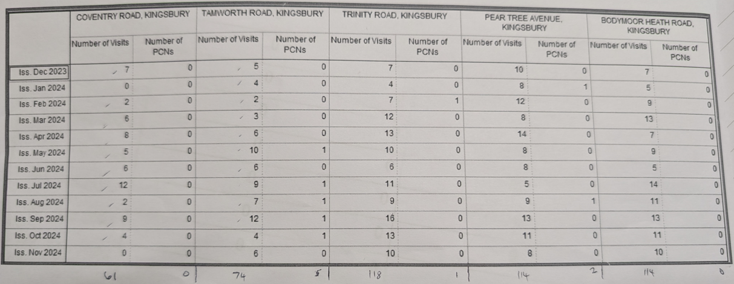  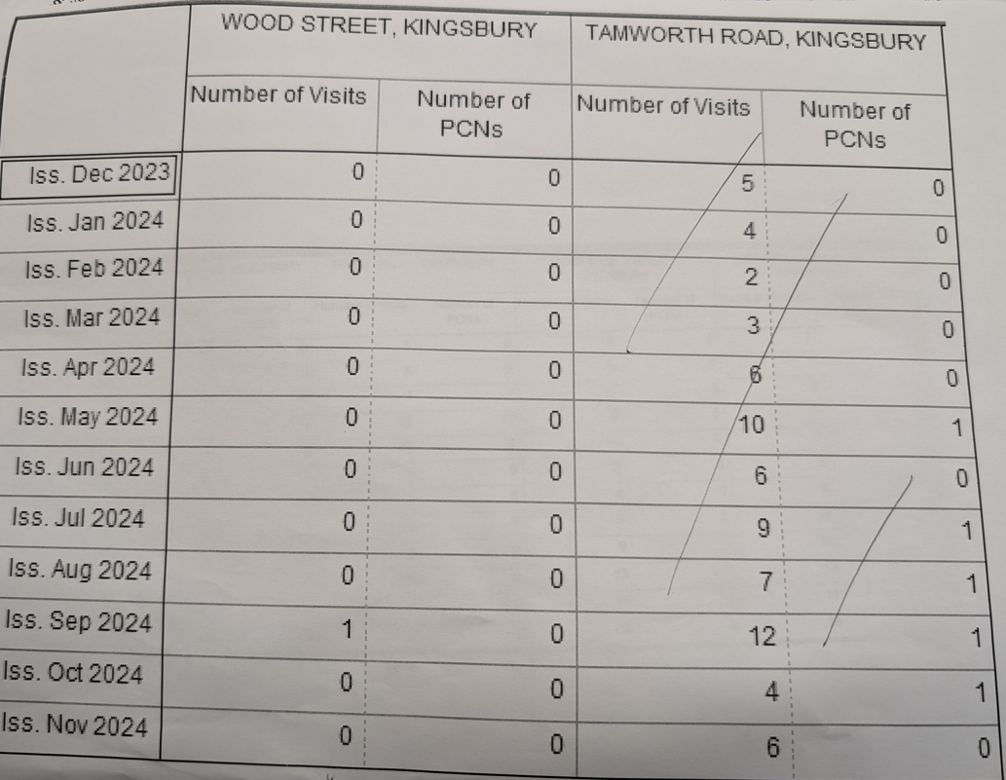  Ref 380: Parish Matters:  - Newly planted tree on the grass verge at Mill Cresent – Cllr A Jenns advised that two new tress will be replaced and that quotes were being sought to fix a metal protection case around the trees. Update confirmed that Cllr A Jenns has received an email confirm that the trees will be replace like for like plus an additional tree planted. Cllr A Jenns to further check if Heanley Road can be replaced too.  - Request for bin next to the new bench on Mill Cresent still required. Cllr J Thomas to get quote and permission from highways. Awaiting Cllr A Jenns to supply contact details to Cllr J Thomas.  - Trees dangerously overhanging the path from the Mill Island Cllr A Jenns to meet with Reece and follow up before reporting back. The trees are scheduled to be collared and maintained shortly but no date has been given.  Ref 393 Parish Matters:  - Parish Boundaries Review - Ongoing, remain on Agenda  Cllr A Jenns believes that Bodymoor Heath may be better becoming part of Kingsbury ward rather than Curdworth due to historic connections and the unity of the Parish Council.  Cllr O Phillips suggested that he saw reason for Ascot Drive to also move to Kingsbury based on proximity to it rather than come under Wood End, Hurley and Piccadilly.  Cllr O Phillips to compile a response on behalf of the parish council.  - Kingsbury Streetlights – Cllr J Thomas confirmed she had spoken to the MP regarding this. Cllr A Jenns to forward email address to Cllr J Thomas for Scott Tomkins (Head of Highways). Cllr O Phillips suggested a complaint is logged and that this should include other villages and not just Kingsbury. Cllr J Thomas to send emails. Still awaiting Cllr A Jenns to provide contact details.  411. Parish Matters:  - Cllr A Phillips (on behalf of Cllr H Phillips) – Big ‘troughs’ towards Baxley Banks and Heally Lane, request Cllr A Jenns talk to County. Cllr A Phillips to send full details to Cllr A Jenns to follow up.  - The area behind Hurley Village Hall has been cleared by the council at the special request of Cllr O Phillips. Whilst doing the works, residents complained about Ivy growing from the halls land over their fences. Cllr J Given has confirmed that residents cut this down and the ivy has collapsed and is just waiting to be cleared now by the HCA. | Cllr A Jenns  Cllr J Thomas  Resolved  Resolved  Resolved  Cllr O Phillips  Cllr A Phillips & Cllr A Wright  Resolved  Cllr J Thomas  Cllr J Thomas & Cllr J Given  Resolved  To monitor  Cllr J Thomas  Cllr J Thomas  Cllr J Thomas  Resolved  Cllr A Jenns  Cllr A Phillips &  Cllr A Jenns  Resolved  Cllr A Jenns  Cllr J Thomas  Cllr A Jenns  Ongoing  Cllr O Phillips  Cllr’s A Jenns and J Thomas  Cllr’s A Phillips and A Jenns  Cllr J Given
402. Kingsbury Parish Recreational Ground:  Confidential Complaint – There has been no further contact from the claimant so the insurance company has closed the issue.  We remain liable for any claim until the child in question turns 21 years of age. Details of insurers at the time should be kept on file in case of a future claim being made for this time duration.  Inspection Reports  Cllr I Thomas expressed concerns about the reports on the playground stating ‘no works required’ despite the above complaint. Cllr I Thomas enquired if a separate independent expert investigation should be made.  The inspection reports of 3rd October, 10th October, 17th October, 24th October, 31st October, 7th November and 14th November were proposed in bulk to be accepted by Cllr O Phillips and seconded by Cllr A Jenns.  Climbing Frame Roof  Cllr I Thomas still awaiting further quotes to remove. | Cllr J Thomas  Cllr I Thomas  Cllr I Thomas
403. Finance Committee:  Recreation Ground Boundary Fence  Three quotes have now been obtained and shared with the council. These can be seen in full in emailed quotes.  - £16,000 without removal of bushes (Nuneaton)  - £13,648 + VAT (Cannock)  - £13,670 + VAT (Secure Fencing)  Discussion around the quotes eliminated the Nuneaton quote due to costs.  Cllr I Thomas said that he was very impressed by the Cannock workmen when they provided the quote for the explored the area fully including its shape and geology to understand the groundworks Vs the other company who measured and provided a quote without through exploration. Cllr H Phillips echoed these views.  Cllr H Phillips proposed proceeding with the quote from the Cannock company. This was seconded by Cllr I Thomas and the council voted unanimously in favour.  Cllr A Phillips to carry out internal audit during the December Christmas Holiday and will audit from July to December in one go.  The next Finance Committee meeting will be on 18th December in Wood End. | Cllrs I Thomas and H Phillips  Cllr A Phillips
404. Policies & Procedures:  Cllr I Thomas has identified one policy which he feels is not fit for purpose which is based around the gifting and awarding of grants. He identified that grant awards are required to be agenda items but that in this meetings case, some applications have come in after the agenda was issued. He also noted that the police does not make reference to this issue as well as failing to include a checking system to ensure that monies awarded are being spent on what has been applied for. Cllr I Thomas asked for permission to rewrite the policy to rectify these issues.  In discussion Cllr O Phillips expressed views that he was against the ideas of making community groups write a formal report. Cllr A Phillips countered with a visual acknowledgment or photographic/public statement being made should be sufficient for proof of successful grant applications.  Cllr I Thomas expressed the need to ensure that all groups have submitted audited accounts and that applications are submitted within appropriate and fixed time frames.  Cllr A Phillips also discussed the lack of consistency within the applications received on how specific costings have been presented and expressed the desire to achieve consistency and expectations.  The above discussion points were acknowledged as needing to be incorporated in a reviewed policy. Cllr I Thomas proposed taking these points to rewrite the policy for the January meeting. This was seconded by Cllr A Phillips and all voted in favour.  Cllr J Thomas proposed that once agreed, we move the grant application form to the front page of the website to make it easier for community groups to find and access.  The Policy and procedures committee hope to bring this and the delegated powers policies to the January meeting. | Cllr I Thomas
405. HR Committee:  Cllr I Thomas left the room during this section of the meeting due to his semi-presence during some of the process as stated in the above declarations.  Cllr A Phillips updated the council on the shortlisting and interview process taken by the HR Committee. That we had had 3 applications, and through effective shortlisting had decided to invite all three to interview. Shortlisting took place on 14th November with Cllrs A Phillips, J Thomas, V Barker and D Bates in attendance. One candidate withdrew their application and the two remaining candidates were interviewed at Piccadilly Community Centre on 25th November. The interview panel was made up of Cllrs J Thomas, A Phillips and D Bates. Through discussion and comparison of question notes the HR committee proposed offering – subject to an enhanced DBS check and the receipt of appropriate references – the position of clerk to the preferred candidate. This was proposed by Cllr A Phillips, seconded by Cllr O Phillips and all councillors voted in favour. Cllr J Thomas will now proceed to contact the successful candidate to formally offer her the position and also contact the unsuccessful candidate. Cllr J Thomas will also seek references and speak to WALC concerning the enhanced DBS check.  Cllr J Thomas expressed the desire to use an independent/neutral venues for the Clerk/Chair supervisions and to have another councillor present during these sessions – possibly Vice Chair Cllr D Bates. She has proposed using Piccadilly Community centre or the Woodlands as a hosting venue for these meetings. Cllr A Phillips seconded the proposal and all councillors voted unanimously. | Cllr J Thomas
406. Data Protection:  Cllr A Phillips offered to continue to research good practice and legislation before making recommendation on how long paperwork and documentation should be held for.  Cllr O Phillips gave a quote to the council concerning the posts associated with digital password storage based on 4 user accounts at an annual cost of £120. The quote will now go to the next finance committee meeting for further discussion. | Cllr A Phillips  Cllr O Phillips and Finance
407. Planning Applications:
Cllr H Phillips abstained from discussion and vote for the following Planning Applications due to being part of the Planning Board at NWBC. Cllr O Phillips also withdrew his voice as a frequent substitute for the Planning Board at NWBC.

- Application: PAP/2024/0498 Cliff - No comments provided by the councillors
- Application: PAP/2024/0519 Kingsbury - No comments provided by the councillors

412. Correspondence Received:  Cllr J Thomas noted the following correspondence:  - Integrated care had been in touch with information regarding their services. She commented to the council that there were 4 questions they were asking, one of which linked to digital usage and that the elderly often don’t have this facility readily available for them to use. That there is little joined up thinking for public transport and not just for Nuneaton but for residents who also need at access Coventry based medical care. It appears that there are plans to have a big overhaul of the NHS.  Cllr J Thomas to write a report to send to WALC, the Parish and the PPG.  - Storage Project Heath Lane, Lea Marston – Discussed generally, Cllr J Thomas to follow up for more information. Ongoing.  - Hillside. There was some confusion as to if Hillside was one or two words with the authority address custodian. | Cllr J Thomas  Cllr J Thomas  Cllr A Jenns
413. Grant Applications:

Community Grants had been applied for from several groups. Each were discussed in turn.

Prior to specific applications, Cllr M Moss expressed some concern over how multiple groups split the pot of money available if they were from the same village believing that the council had previously stated that each village had a maximum amount of £500 available. This was raised as a result of grant applications being received by both Wood End Village Hall and Wood End 1st Scout Group. Cllr J Thomas checked the policy and confirmed that this point isn’t mentioned within it.
Cllr A Jenns expressed that his understanding mirrored Cllr M Moss’s view but also conceded that funds based per village is also inherently wrong due to population numbers etc.
Cllr A Phillips raised the point that she disagreed with any specific ring fencing of grant funds to specific villages. In this case the Scout group is based within Wood End but is the only Scout group and offers activities and support for children across the parish therefore neither the scout group, nor the village itself should be penalised for a name.

Wood End Village Hall applied for £500 towards the costs of the village Christmas tree, new decorations and outdoor lights. Cllr I Thomas proposed granting the full £500 amount. Cllr V Barker seconded. All eligible councillors’ voted in favour. Cllrs A, O and H Phillips withdrew from discussion.

Kingsbury Good Neighbour group applied for £500 towards the cost of a village Christmas tree and to provide PP children from the area with Christmas presents at the discretion and in unison with the school Head teachers. Cllr A Jenns abstained from the discussion. The full amount was proposed by Cllr I Thomas and seconded by Cllr O Phillips. All voted in favour.
Cllr I Thomas made the additional proposal to add a £250 extra donation to the KGN Groups towards the present scheme for PP children at the school. This was seconded by Cllr O Phillips and all voted in favour (excluding Cllr A Jenns).

Wood End Scouts applied for £500 towards the costs of purchasing new torches, Hi-vis vests and litter-picking equipment. Cllr H Phillips proposed the full £500 amount be granted which was seconded by Cllr O Phillips. All voted in favour.

Hurley Village Hall applied for £500 for decorations and for new lights for the outdoor Christmas tree as well as the cost of a cherry picker to install the new lights. Cllr O Phillips proposed the full grant amount be awarded which was seconded by Cllr M Moss. Cllr J Given removed himself from discussion on this matter. All other councillors voted in favour.

414. Accounts for Payment:  Cllr J Thomas provided the following (as per Accounts for Payment Document 27th November 2024):  - EE £8.00  - 2-year contract due to expire 27th October 2024. Cost £8.00 per month.  - Piccadilly Grant £500  - Remembrance Wreath £27.25  - Room Hire £25.00  - Website Fees £460.00  - Cleaning Costs £270.00  - Laptop Repair £30.00  - Phone protector and replacement cable £29.99  - Chair’s Chain of Office Engraving £15.00  - Postage £1.75  - Cllr J Thomas Travel Expenses £21.60  - Domain Name £150.00  - Email Storage £60.00  - ICO £35.00  Cllr J Thomas also informed the council of the following received amounts:  - HMRC £365.00  - Interest on accounts £93.21  It was also discussed that the parish had resolved at the last meeting to return funds to the KGN group at £784.08 as well as having approved grant awards of £2000.00 in today’s meeting.  It was proposed by Cllr I Thomas and seconded by Cllr M Moss to move £3802.42 from the reserves account to the current account to pay the above payments. All councillors in favour.  All payments agreed. Proposed by Cllr I Thomas, and Seconded by Cllr M Moss, No one Against or Abstained, all Cllr’s in Favour. All PO’s signed by Cllr I Thomas and Cllr M Moss. Cllr J Thomas to make payments.  Resolved: That the accounts listed above be approved for payment  Bank Balances at at 30th November 2024  Current Account £675.60  Reserve Account £73862.11  It was further discussed that payments for December may need to be made which are foreseen to be only the costs of the mobile phone bill at £8. Cllr O Phillips proposed that any emergency funds required for December were passed onto the council to be decided upon via email. This was seconded by Cllr A Phillips and all voted in favour. | Cllr J Thomas
415. Parish Matters:  - Cllr I Thomas mentioned that the bleed bags will be expiring shortly. Replacement prices vary from £40-£60 per bag + VAT. He wanted to ask the council if they were to be replaced or removed. Cllr O Phillips spoke passionately about removing them from the De-fib cases in favour of using funds to educate local community groups and businesses and provide/pursue a more active measure for life loss prevention. This is to be added to the January agenda for further discussion. Many other councillors didn’t realise that these bleed bags were in the de-fib cases and expressed that this was possibly the case for most residents. Cllr M Moss seconded the proposal to remove them in favour of exploring more active options. Cllr I Thomas voted against this, whilst 8 councillors voted in support of Cllr O Phillip’s motion.  - Cllr J Given reported a damaged drain cover on the black path. The information has already been forwarded on to Reece as urgent but still nothing seems to have been done.  - Cllr M Moss reported that an area of grass by Mill Crescent has been churned up between the bollards due to poor parking. Can a request be made to close the gap between bollards to stop this happening?  - Cllr A Phillips let the council know about the Wood End Village hall Christmas Fayre taking place on Saturday and invited all councillors to attend.  - Cllr J Thomas invited all councillors to attend the afternoon tea being hosted at Victory Hall on 15th December from 2pm-4pm.  - Cllr I Thomas reported a pot hole outside of Number 7 in Piccadilly. He also reported continual issues with Fed Ex lorries which are causing significant damage to cars as they reverse and move around the village. There have been some very near misses with risk of life. It was agreed that the parish would write to Fed Ex to put signs up and to tell their drivers about access using Junction 10.  Cllr J Thomas wished all councillors a merry Christmas, a happy new year and all the best for 2025. This was echoed to each other from all councillors. | January Agenda, Cllrs I Thomas and O Phillips  Cllr J Given  Cllr J Thomas  Cllr J Thomas

Next meetings
Monthly Parish Meeting  AGM | 16th January  20th February  19th March  16th April  21st May | Jubilee Court, Kingsbury  Piccadilly Community Centre  Wood End Community Room, Wood End  Jubilee Court, Kingsbury  Victory Hall, Bodymoor Heath

Signed __________________________________ Dated__________________________

