Kingsbury Parish Council Minutes

Meeting of Kingsbury Parish Council held on Thursday 16th October 2025, at 6:45pm at Jubilee Community Centre, Kingsbury.

Present Councillors: Cllrs J Thomas, I Thomas, A Jenns, J Given, V Barker, H Phillips, M Wilson, D Bates, SJ Green

Apologies: Received and accepted, Cllrs A Phillips, O Phillips, M Moss

Minute Taker: R Lillico, Clerk

Notes | Action
569. Public Participation
Two members of the public were in attendance and addressed the council.

570. Police Matters
PC Beale was unable to attend the meeting in person. No police matters were raised.
571. Apologies
As noted, above.

572. Declaration of Personal and Prejudicial Interests
All Declarations of Personal and Prejudice Interests as follows:
- Councillors J Thomas and I Thomas declared a personal interest in any minutes relating to HS2.
- Councillors I Thomas and J Thomas declared a personal interest in any minutes relating to the Special Management Zone in North Warwickshire
- Councillor J Thomas declared a personal interest in any minutes concerning Bodymoor Heath Victory Hall Committee and Piccadilly Community Centre.
- Councillor I Thomas declared a personal interest in any minutes concerning Piccadilly Community Association.
- Councillor A Phillips declared a personal interest in any issues relating to Wood End Village Hall and Hurley Primary School.
- Councillor A Jenns declared a personal interest in any issues relating to NWBC and WCC.
- Councillor D Bates declared a personal interest in any issues relating to NWBC.
- Councillor H Phillips declared a personal interest in any issues relating to NWBC.
- Councillor O Phillips declared a personal interest in any issues relating to NWBC and Wood End Village Hall.
- Councillor M Wilson declared a personal interest in any issues relating to The Royal Oak, Kingsbury.

Cllr J Thomas declared an interest in the grant application received from Bodymoor Heath.
Cllr A Jenns declared an interest in the grant application received from Methodist Café.
Cllr J Given declared an interest in planning application PAP/2025/0449.

573. To Receive and Approve Minutes
The minutes of the meetings of Parish Council and Annual Meeting held on Wednesday 17th September 2025 were received & approved as a correct record.

Proposed by Cllr J Given and Seconded by Cllr A Jenns. All Councillors in Favour. – Minutes signed by Cllr J Thomas.

574. Matters Arising from Previous Minutes:  Item 295:  Bin Dexter Lane: Clerk is awaiting quote for fortnightly empty of bins and confirmation of location of bin. To report back next month.  Ref 314:  - Travellers Site: No updates this month.  Ref 350: HS2 Report: Cllr I Thomas reported that HS2 have deferred works in the area and are concentrating on the Birmingham area for the next 4 years. Cllr I Thomas will report back to the council following his attendance at a further HS2 meeting next month.  Ref 380: Parish Matters:  - Bin at Mill Crescent: per notes in item 295, above.  Ref 432. Parish Matters:  - Damaged signs: Cllr J Thomas has reported again at SMZ meeting – hopes to have an update next month. To remain on agenda as works are expected to take some time.  Ref 489. Parish Matters:  - Sewage on Black Path – Clerk reported that Severn Trent have confirmed this issue has been resolved.  Ref 512. Parish Matters:  - Uneven path near letterbox, Kingsbury – Clerk still awaiting response from WCC.  Ref 525. Mayor Community Grants: Cllr D Bates requested that the remainder of agreed donation is now provided. All Cllr’s agreed.  Ref 529. Parish Matters:  - Noisy railway line – clerk noted National Rail are looking in to this and will provide a further update when available. Cllr D Bates noted that the noise is getting worse, particularly near bridge.  - Lorries outside of scrapyard – clerk sent letter to EMR and CC’d MP. Clerk to report back once response received.  - Piccadilly parking areas – no update this month.  Ref 532. Motion: No update this month.  Ref 557. Grants: Hurley Church have not yet been paid as further bank details were required; now received and scheduled for payment October.  Ref 558. Community Awards: Cllr J Thomas noted thanks had been received from attendees of the Community Awards and expressed thanks for Mayor Debbie Bates and family for their input and presentation, and to Cllr M Wilson for providing the food for the event.  Ref 562. Planning Applications: PAP/2025/0414. Clerk received confirmation from the planning department that consent is required for any works to a Tree Preservation Order even general maintenance works. In this instance consent has been requested for the removal of lower branches and epicormic growth.  Ref 565. Parish Matters:  - Yellow lines – Cllr I Thomas and SJ Green met with Highways to discuss and will provide further update.  - Dropped Kerbs – It was reported that Highways have deemed these very unlikely as there are now so many dropped kerbs in the area.  - High court injunction signs have been removed.  - Flattened Bollards – Clerk reported. No update this month.  - Campervan signs – clerk reported.  - Trees – Clerk reported.  - Trenches – Clerk reported. | Clerk  To monitor  Cllr I Thomas  Clerk  To monitor  Resolved  Clerk  Cllr I Thomas  Clerk  Clerk  Cllr SJ Green  Ongoing  Resolved  Resolved  Resolved  Cllrs I Thomas & SJ Green  Resolved  Resolved  Clerk
575. Finance Committee  Bank Mandate: Cllr J Thomas & I Thomas working on getting this sorted.  Community Awards: Cllr I Thomas asked Cllr M Wilson for an invoice for the food supplied for the community awards.  Pre-budget update: Cllr I Thomas reported that council finances are running smoothly, with only a couple of expected minor overspends. A quarterly finance meeting will be arranged and full council update available next month.  De-fib costs in December: Cllr I Thomas requested advance permission to purchase new defib pads in December as these are expected to be replaced. All Cllr’s agreed | Cllr J Thomas  Cllr M Wilson  Cllr I Thomas  Resolved
576. Grant Applications  Cllr J Thomas expressed her thanks on behalf of Piccadilly Community Association for the Firework Night Grant.  Kingsbury Aquarius – It was proposed to reject this application as it does not meet the criteria of the Grants Policy. Proposed by Cllr I Thomas and Seconded by Cllr H Phillips. All Councillors in Favour.  Hurley Kings – It was proposed to reject this application as it was made on behalf of Hurley Kings, not Hurley Kings themselves. Proposed by Cllr H Phillips and Seconded by Cllr M Wilson. All Councillors in Favour.  Hurley Community Association – It is believed that this work has already been carried out. If so, a Grant cannot be provided so it has been suggested that funding is sought from Cllrs H Phillips and O Phillips.  Methodist Community Café – Accounts and Constitution were not provided with the application. It was agreed that the grant would be given upon receipt of these documents. Proposed by Cllr D Bates and Seconded by Cllr J Given. All Councillors in Favour.  Bodymoor Heath Committee – Grant application successful. Proposed by Cllr I Thomas and Seconded by Cllr V Barker. All Councillors in Favour. | Resolved  Resolved  Resolved  Resolved  Resolved
577. Kingsbury Parish Recreational Ground:  Inspection Reports  Cllr J Thomas advised that Inspection Reports had been emailed to all Cllrs. All Cllr’s confirmed receipt. Cllrs discussed the differences between the monthly reports and the annual report. Clerk to seek further advice from NWBC and report back.  Working Party  No update this month. | Clerk  Working Party
578. Policies & Procedures:
No new Policies & Procedures were bought to this meeting.

579. Planning Applications:
PAP/2025/0429, PAP/2025/0449, PAP/2025/0452, PAP/2025/0478, PAP/2025/0476. No objections raised.

580. Neighbourhood Plan:  Cllr J Thomas noted that she does not believe there is much of an appetite amongst councillors to undertake a Neighbourhood Plan. Councillors agreed that they believe the amount of work and cost would not outweigh the benefit of the plan. Kingsbury Parish is a difficult parish to set a Neighbourhood plan for as it comprises of 5 villages plus hamlets, all with different needs. Instead, it was suggested that the council take a more pro-active approach to planning applications, perhaps by setting up a planning committee to provide much more qualitative comments on applications. Cllr J Thomas will look in to a sub-committee and any training available. | Cllr J Thomas
581. Parish Matters:  - Cllrs V Barker, H Phillips, M Wilson & I Thomas had nothing to report.  - Cllr D Bates reported broken slabs on Pear Tree Ave. Council have lifted these previously but not re-laid  - Cllr D Bates reported that there had been a recent car accident on the ‘mad mile’ and a defib was required but could not be located. The nearby shop has suggested that they are happy to have one there. Cllr M Wilson noted that the one by the pub is self-funded – he will provide further details to Cllr D Bates.  - Cllr D Bates reported that speeding is still a big issue in Kingsbury. Clerk noted that Cllr SJ Green has been looking in to the availability of cameras. More update next expected next month.  - Cllr A Jenns reported a vandalised tree on Coventry Road between the entrances to Mill Crescent. | Clerk  Cllr M Wilson  Clerk
582. Correspondence received  Cllr J Thomas noted a letter had been received with respect to an inadequate bus shelter. Clerk to report to WCC although Cllr A Jenns informed the council that WCC does not provide bus shelters anymore so they may not fix this. | Clerk
583. Accounts for Payment:  The clerk provided the following (as per Accounts for Payment Document 13th October 2025).  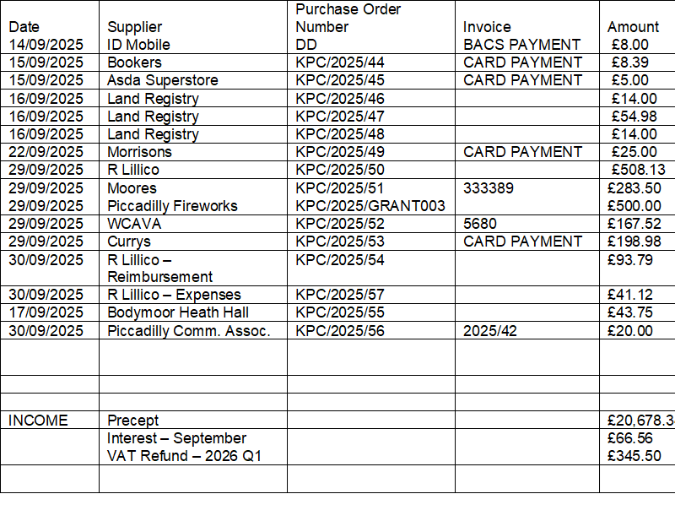  All payments agreed. Proposed by Cllr H Phillips, and Seconded by Cllr M Wilson. All Cllr’s in Favour. All PO’s signed by Cllr H Phillips and Cllr M Wilson. Cllr J Thomas to make payments.  Resolved: That the accounts listed above be approved for payment  Bank Balances on 30thSeptember 2025  Current Account £2,553.67  Reserve Account £83,008.94 | Cllr J Thomas
584. Confidential Items
That under Section 100A of the Local Government Act 1972, in view of the nature of business to be transacted – it is advisable to temporarily exclude the public and press from the meeting as there would be disclosure to them of exempt information under paragraph 1 and 11 of Part 1 of Schedule 12A of the said Act.
This will be recorded as a separate item confidential.

585. Meeting Closed
The meeting closed at 21.20.

Next meetings
Monthly Parish Meeting | Thurs 20th November 2025 | Piccadilly Community Centre
Monthly Parish Meeting | Weds 21st January 2026 | Jubilee Community Room, Kingsbury
Monthly Parish Meeting | Weds 25th February 2026 | The Woodlands, Wood End
Monthly Parish Meeting | Weds 18th March 2026 | Piccadilly Community Centre
Monthly Parish Meeting | Weds 15th April 2026 | Jubilee Community Room, Kingsbury
Annual General Meeting of the Council  Monthly Parish Meeting  Annual Parish Meeting | Weds 20th May 2026  6pm Start  6.15pm Start  7.30pm start | Victory Hall, Bodymoor Heath
Meetings start at 7.00pm. (Public questions are taken at the start of a meeting (6.45pm) for 10 minutes and not minuted)

Signed __________________________________ Dated__________________________

