Kingsbury Parish Council Minutes

of meeting held at 6:45pm, Thursday 26th February 2026 at The Woodlands, Wood End

Present Councillors: Cllrs J Thomas, I Thomas, A Jenns, J Given, V Barker, O Phillips, M Moss, M Wilson, SJ Green

Apologies: Received and accepted, Cllrs D Bates, H Phillips, A Philips

Minute Taker: R Lillico, Clerk

Notes | Action
621. Public Participation
No members of the public attended this meeting.

622. Mr R Fenwick – address to council regarding road issues
Mr Fenwick, Director of Highways, addressed the council and apologised for the time taken to deal with various matters round the parish, particularly Bodymoor Heath Road. He reported that WCC are reviewing the speed limit and it is suggested that this may be reduced to 50mph with further signed reductions for road narrowing’s and bridge together with warning and flashing signs. Cllrs agreed this would help and that any measures would be beneficial. This would be implemented as quickly as fabrication times allow.
In addition to the above, a longer-term solution for lights would be considered. Mr Fenwick noted that from April 2026 there would be more funding allocated to road safety and Cllr SJ Green confirmed he was aware of funding that may be available for Bodymoor Heath Road.

Mr Fenwick showed Cllrs a new online tool that will allow users to report road issues and view associated planned/completed works.

Cllr M Moss asked if Highways surveyed the quality of work completed by sub-contractors as the pot hole filling on Trinity Road, Kingsbury had only lasted a couple of days and appeared to be poor quality of work. Mr Fenwick confirmed that spot checks were carried out and sub-contractors were required to provide evidence of job completion. He noted that surveying every job was almost impossible as there are so many. Mr Fenwick noted that whilst many current pot holes are being filled temporarily, this is due to the number of them but this approach allows for better management of all jobs. He reported that from May 2026, Highways are aiming for 90% of repairs to be more substantial ‘cut and patch’ fills.

Cllr I Thomas thanked Cllr SJ Green, Cllr A Jenns and Mr Fenwick for all they’ve done in addressing the issues on Bodymoor Heath road so far.

623. Police Matters
No representative of the police attended this meeting.
Cllr I Thomas reported that some individuals appeared to be trying to open cars in Piccadilly. Cllr M Wilson noted a suspicious vehicle in Kingsbury.
624. Apologies
As noted, above.

625. Declaration of Personal and Prejudicial Interests
All Declarations of Personal and Prejudice Interests as follows:
- Councillors J Thomas and I Thomas declared a personal interest in any minutes relating to HS2.
- Councillors I Thomas and J Thomas declared a personal interest in any minutes relating to the Special Management Zone in North Warwickshire
- Councillor J Thomas declared a personal interest in any minutes concerning Bodymoor Heath Victory Hall Committee and Piccadilly Community Centre.
- Councillor I Thomas declared a personal interest in any minutes concerning Piccadilly Community Association.
- Councillor A Phillips declared a personal interest in any issues relating to Wood End Village Hall and Hurley Primary School.
- Councillor A Jenns declared a personal interest in any issues relating to NWBC and WCC.
- Councillor D Bates declared a personal interest in any issues relating to NWBC.
- Councillor H Phillips declared a personal interest in any issues relating to NWBC.
- Councillor O Phillips declared a personal interest in any issues relating to NWBC and Wood End Village Hall.
- Councillor M Wilson declared a personal interest in any issues relating to The Royal Oak, Kingsbury.

626. To Receive and Approve Minutes
The minutes of the meetings of Parish Council Meeting held on Wednesday 21st January 2026 were received & approved as a correct record.

Proposed by Cllr I Thomas and Seconded by Cllr J Given. All Councillors in Favour. – Minutes signed by Cllr J Thomas.

627. Matters Arising from Previous Minutes:  Item 295:  Bin Dexter Lane: Clerk has requested permission from NWBC to place this bin, and the bin at Mill Crescent (ref380) and is awaiting response.  Ref 314:  - Travellers Site: No updates this month.  Ref 350: HS2 Report: Cllr I Thomas reported that affects of the A446 closure had better than expected and noted further weekend closures were expected.  Ref 380: Parish Matters:  - Bin at Mill Crescent: per notes in item 295, above.  Ref 432. Parish Matters:  - Damaged signs: Cllr SJ Green to chase again but noted that many signs are delayed due to design team shortages.  Ref 512. Parish Matters:  - Uneven path near letterbox, Kingsbury – It as noted that as this is an unofficial walked pathway, it is unlikely to be fixed.  Ref 529. Parish Matters:  - Noisy railway line – no update this month, clerk was advised this would take some time.  - Lorries outside of scrapyard – No update this month. Cllr M Wilson reported fewer lorries but always at lease one waiting. Clerk to chase letter and Cllr SJ Green to see if CC can assist.  - Piccadilly parking areas – Cllr SJ Green noted that a commencement date of 23/03/26 had been set and all local residents will receive notification in writing.  Ref 565. Parish Matters:  - Yellow lines – no update this month but Cllr I Thomas noted that the road had been marked up.  - Dropped Kerbs – Cllr SJ Green reported that the kerbs were going ahead but no scheduled date as yet.  - Flattened Bollards – Not yet replaced. Clerk to chase  - Trees – no update this month.  - Trenches – no update this month.  Ref 581. Parish Matters:  - Broken slabs, Pear Tree Ave – no update this month  - Defib by shops in Kingsbury – Cllr Wilson has provided Clerk and D Bates with defib contact details.  - Speeding, Kingsbury Road – Cllr SJ Green reported that this is in progress and will update the parish council accordingly.  Ref 599. Parish Matters:  - Fencing around meadow – no update this month.  - Football goals – Cllr J Given to provide future updates.  - Trees overhanging bench at Mill Crescent. Highways have confirmed this is landowner responsibility and have been in touch.  Ref 611. To agree appointment of Internal and External Auditors:  Cllr J Thomas reported that the internal audit has been booked will Bill Wooliscroft for 21 April 2026.  Ref 615. Local Plan:  Cllr J Thomas noted that Dorothy had received and accepted her email sent on behalf of Kingsbury Parish Council.  Ref 618. Parish Matters:  - Potholes on Wood St and Boulters Lane, Wood End - reported.  - Wood End sign - reported  - Pruning of Concrete path in the rec - reported  - Grit bins in Mill Crescent and Edge Hill – permission requested.  - Black Path – Cllrs J Given and SJ Green are in contact with STW and this is being resolved.  - Bus Shelter – this is owned by WCC. Cllr SJ Green to chase.  - Trinity road resurfacing - reported | Clerk  To monitor  Cllr I Thomas  Clerk  To monitor  Closed  To monitor  Clerk & SJ Green  To monitor  Cllr SJ Green  Cllr SJ Green  Clerk  Clerk  Clerk  Clerk  Cllr D Bates  Cllr SJ Green  Clerk  Cllr J Given  Closed  Resolved  Closed  Clerk  Clerk  Clerk  Clerk  Cllr J Given & SJ Green  Cllr SJ Green  Clerk
628. Finance Committee  Maintenance Contract: Cllrs confirmed they had received a copy of the maintenance contract quote prior to this meeting. Cllr I Thomas ran through the items and noted that the contract will be fixed for one year only. The quote was accepted by the council and agreed for the clerk to sign and return to NWBC. Proposed by Cllr I Thomas, and Seconded by Cllr J Given. All Cllr’s in Favour.  Payroll: Cllrs confirmed they had received a copy of WCAVAs email notification of payroll service termination. Cllr I Thomas noted that other providers will cost significantly more, based on a few quotes received and recommended that the clerk, plus one Cllr, process the payroll each month. This will be on a 6-month trial basis, beginning 1st April 2026. Proposed by Cllr I Thomas, and Seconded by Cllr M Wilson. All Cllr’s in Favour.  Internal control report: Due to the absence of Cllr A Phillips who was responsible for undertaking the internal review, this item will be moved to the March meeting. | Resolved  Resolved  Cllr A Phillips
629. Kingsbury Parish Recreational Ground:  Inspection Reports  Cllr J Thomas advised that Inspection Reports had been emailed to all Cllrs. All Cllr’s confirmed receipt.  Quotes for new play equipment:  All Cllrs confirmed receipt of quotes and plans from three companies that were emailed over prior to the meeting.  - Kompan £135,568 exc. VAT  - Wicksteed £91,510 exc. VAT  - Sutcliffe £84,356 exc. VAT  Cllrs all agreed that the Sutcliffe quote and plan was preferred; it provides better value for money and so far, pleasing customer service. Cllrs requested that an additional wheelchair accessible roundabout is added.  Cllr J Thomas noted that there is a meeting planned with the working group and Eleanor Evans to determine funding options. It was proposed to give delegated powers to the working group to proceed with the quote and funding applications as suggested by the working group. Proposed by Cllr I Thomas, and Seconded by Cllr O Phillips. All Cllr’s in Favour. | Working Party
630. Policies & Procedures:  Cllrs confirmed receipt of the new policies recommended by the policies committee: Grants Application Form, Grievance Policy, Complaints Procedure, Risk Assessment, Document Retention Policy, Own Device Fact Sheet. Proposed by Cllr I Thomas, and Seconded by Cllr O Phillips. All Cllr’s in Favour. | Resolved
631. Planning Applications:
Cllrs discussed planning application references:
PAP/2025/0556, PAP/2025/0557, PAP/2026/0016, PAP/2026/0040
PAP/2026/0056, PAP/2026/0066. No objections raised. Cllr J Given gave support for PAP/2026/066 as a venture that will provide local growth and employment opportunities.

632. Accounts for Payment:
The clerk provided the following (as per Accounts for Payment Document 23rd February 2026).
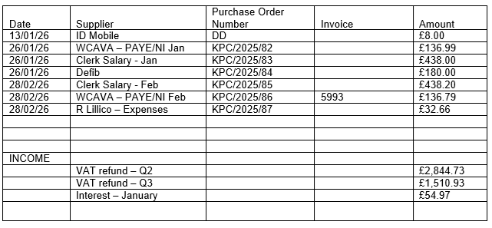
All payments agreed. Proposed by Cllr I Thomas, and Seconded by Cllr M Moss. All Cllr’s in Favour. All PO’s signed by Cllr V Barker and Cllr A Jenns. Cllr J Thomas to make payments.
Resolved: That the accounts listed above be approved for payment
Bank Balances on 31st January 2026
Current Account £5,622.87
Reserve Account £70,459.20

The following payments on account were paid in December 2025, prior approval was given for all payments in November 2025 as no meeting is held in December. All PO’s signed by Cllr A Phillips and Cllr O Phillips.
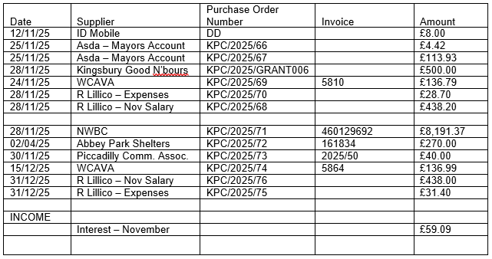

633. Correspondence Received
Cllr J Thomas raised an email received from Warwickshire Police requesting feedback.

634. Parish Matters:  Cllrs M Moss, J Given, M Wilson, I Thomas, V Barker, O Phillips, J Thomas had nothing to report.  - Cllr A Jenns reported the water stop cover outside no.57 Coventry Road, Kingsbury was broken and needs to be replaced. | Clerk to report all matters
635. Confidential Items
That under Section 100A of the Local Government Act 1972, in view of the nature of business to be transacted – it is advisable to temporarily exclude the public and press from the meeting as there would be disclosure to them of exempt information under paragraph 1 and 11 of Part 1 of Schedule 12A of the said Act.
This will be recorded as a separate item confidential.

636. Meeting Closed
The meeting closed at 20.49. Cllr SJ Green and clerk left.

The meeting was resumed shortly afterwards for a confidential item (minute no.635); minutes were taken by Cllr J Thomas, Chair, and will be recorded separately.

Next meetings
Monthly Parish Meeting | Weds 18th March 2026 | Piccadilly Community Centre
Monthly Parish Meeting | Weds 15th April 2026 | Jubilee Community Room, Kingsbury
Annual General Meeting of the Council  Monthly Parish Meeting  Annual Parish Meeting | Weds 20th May 2026  6pm Start  6.15pm Start  7.30pm start | Victory Hall, Bodymoor Heath
Meetings start at 7.00pm. (Public questions are taken at the start of a meeting (6.45pm) for 10 minutes and not minuted)

Signed __________________________________ Dated__________________________

